Rockbuster

Stealth LLC

Data Dictionary

**Table of Contents**

1. **Rockbuster Entity Relationship Diagram (ERD)………………………3**
2. **Fact Tables…………………………………………………………………4**
   1. **Payment………………………………………………………………………4**
   2. **Store…………………………………………………………………………..4**
   3. **Film_actor……………………………………………………………………4**
   4. **Film_category………………………………………………………………..4**
3. **Dimension Tables………………………………………………………….5**
   1. **Rental…………………………………………………………………………5**
   2. **Inventory……………………………………………………………………...5**
   3. **Customer……………………………………………………………………...5**
   4. **Staff……………………………………………………………………………6**
   5. **Actor…………………………………………………………………………..6**
   6. **Film……………………………………………………………………………7**
   7. **Category………………………………………………………………………7**
   8. **Address………………………………………………………………………..7**
   9. **Language……………………………………………………………………...8**
   10. **City…………………………………………………………………………….8**
   11. **Country………………………………………………………………………..8**

**1. Rockbuster Entity Relationship Diagram (ERD):**

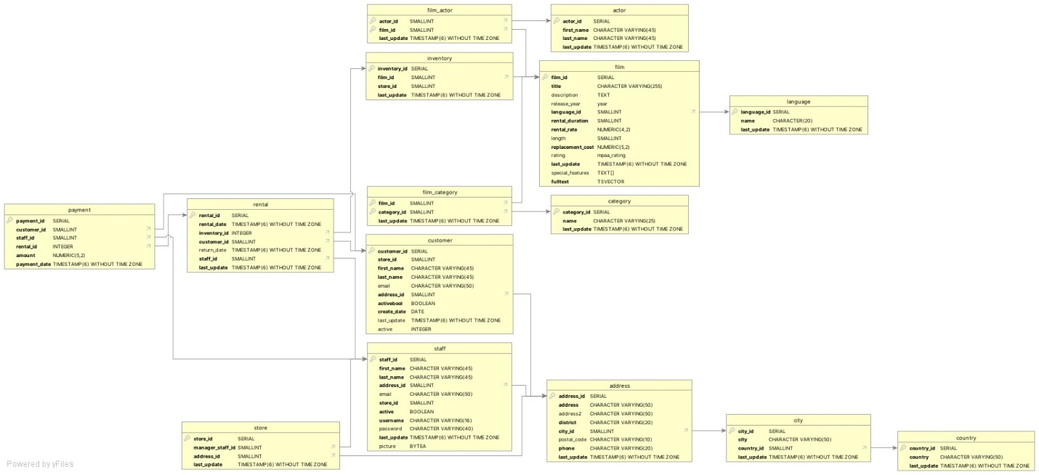

**2. Fact Tables**

**2.1. Payment**

|  |  |  |  |  |
| --- | --- | --- | --- | --- |
| **Key** | **Column** | **Data Type** | **Description** | **Links** |
| Primary | Payment_id | SERIAL | Primary key, unique identifier for a payment |  |
| Foreign | Customer_id | SMALLINT | Unique identifier for a customer | Links to customer table. |
| Foreign | Staff_id | SMALLINT | Unique identifier for a staff member | Links to staff table |
| Foreign | Rental_id | INTEGER | Unique identifier for a rental | Links to rental table |
|  | Amount | NUMERIC(5,2) | Total amount of purchase |  |
|  | Payment_date | TIMESTAMP (6) WITHOUT TIME ZONE | Date and time payment was made not including time zone |  |

**2.2. Store**

|  |  |  |  |  |
| --- | --- | --- | --- | --- |
| **Key** | **Column** | **Data Type** | **Description** | **Links** |
| Primary | Store_id | SERIAL | Primary key, unique identifier for a store |  |
| Foreign | Manager_staff_id | SMALLINT | Unique identifier for a staff manager | Links to staff table |
| Foreign | Address_id | SMALLINT | Unique identifier for a store address | Links to address table |
|  | Last_update | TIMESTAMP (6) WITHOUT TIME ZONE | Date and time of last record update |  |

**2.3. Film_actor**

|  |  |  |  |  |
| --- | --- | --- | --- | --- |
| **Key** | **Column** | **Data Type** | **Description** | **Links** |
| Primary/  Foreign | Actor_id | SMALLINT | Primary key, unique identifier for an actor | Links to actor table |
| Primary/  Foreign | Film_id | SMALLINT | Primary key, unique identifier for a film | Links to film table |
|  | Last_update | TIMESTAMP (6) WITHOUT TIME ZONE | Date and time of last record update |  |

**2.4. Film_category**

|  |  |  |  |  |
| --- | --- | --- | --- | --- |
| **Key** | **Column** | **Data Type** | **Description** | **Links** |
| Primary/  Foreign | Film_id | SMALLINT | Primary key, unique identifier for a film | Links to film table |
| Primary/  Foreign | Category_id | SMALLINT | Primary key, unique identifier for a film category | Links to category table |
|  | Last_update | TIMESTAMP (6) WITHOUT TIME ZONE | Date and time of last record update |  |

**3. Dimension Tables**

**3.1. Rental**

|  |  |  |  |  |
| --- | --- | --- | --- | --- |
| **Key** | **Column** | **Data Type** | **Description** | **Links** |
| Primary | Rental_id | SERIAL | Primary key, unique identifier for a rental | Links from payment table |
|  | Rental_date | TIMESTAMP (6) WITHOUT TIME ZONE | Date and time of rental |  |
| Foreign | Inventory_id | INTEGER | Unique identifier for an inventory item | Links to inventory table |
| Foreign | Customer_id | SMALLINT | Unique identifier for a customer | Links to customer table |
|  | Return_date | TIMESTAMP (6) WITHOUT TIME ZONE | Date and time of return date |  |
| Foreign | Staff_id | SMALLINT | Unique identifier for a staff member | Links to staff table |
|  | Last_update | TIMESTAMP (6) WITHOUT TIME ZONE | Date and time of last record update |  |

**3.2. Inventory**

|  |  |  |  |  |
| --- | --- | --- | --- | --- |
| **Key** | **Column** | **Data Type** | **Description** | **Links** |
| Primary | Inventory_id | SERIAL | Primary key, unique identifier for an inventory item | Links from rental table |
| Foreign | Film_id | SMALLINT | Unique identifier for a film | Links to film table |
|  | Store_id | SMALLINT | Unique identifier for a store |  |
|  | Last_update | TIMESTAMP (6) WITHOUT TIME ZONE | Date and time of last record update |  |

**3.3. Customer**

|  |  |  |  |  |
| --- | --- | --- | --- | --- |
| **Key** | **Column** | **Data Type** | **Description** | **Links** |
| Primary | Customer_id | SERIAL | Primary key, unique identifier for a customer | Links from payment and rental tables |
|  | Store_id | SMALLINT | Unique identifier for a store |  |
|  | First_name | CHARACTER VARYING (45) | Customer’s first name |  |
|  | Last_name | CHARACTER VARYING (45) | Customer’s last name |  |
|  | Email | CHARACTER VARYING (50) | Customer’s email address |  |
| Foreign | Address_id | SMALLINT | Customer’s home address | Links to address table |
|  | Activebool | BOOLEAN | If customer is active (true/false) |  |
|  | Create_date | DATE | Date customer account was created |  |
|  | Last_update | TIMESTAMP (6) WITHOUT TIME ZONE | Date and time of last record update |  |
|  | Active | INTEGER | If customer is active (binary |  |

**3.4. Staff**

|  |  |  |  |  |
| --- | --- | --- | --- | --- |
| **Key** | **Column** | **Data Type** | **Description** | **Links** |
| Primary | Staff_id | SERIAL | Primary key, unique identifier for a staff member | Links from payment, store, and rental tables |
|  | First_name | CHARACTER VARYING (45) | First name of staff member |  |
|  | Last_name | CHARACTER VARYING (45) | Last name of staff member |  |
| Foreign | Address_id | SMALLINT | Unique identifier for a store address | Links to address table |
|  | Email | CHARACTER VARYING (50) | Email address of staff member |  |
|  | Store_id | SMALLINT | Unique identifier for a store |  |
|  | Active | BOOLEAN | If staff member is active (true/false) |  |
|  | Username | CHARACTER VARYING (16) | Staff member’s username |  |
|  | Password | CHARACTER VARYING (40) | Staff member’s password |  |
|  | Last_update | TIMESTAMP (6) WITHOUT TIME ZONE | Date and time of last record update |  |
|  | Picture | BYTEA | Picture of staff member |  |

**3.5. Actor**

|  |  |  |  |  |
| --- | --- | --- | --- | --- |
| **Key** | **Column** | **Data Type** | **Description** | **Links** |
| Primary | Actor_id | SERIAL | Primary key, unique identifier for an actor | Links from film_actor table |
|  | First_name | CHARACTER VARYING (45) | First name of actor |  |
|  | Last_name | CHARACTER VARYING (45) | Last name of actor |  |
|  | Last_update | TIMESTAMP (6) WITHOUT TIME ZONE | Date and time of last record update |  |

**3.6. Film**

|  |  |  |  |  |
| --- | --- | --- | --- | --- |
| **Key** | **Column** | **Data Type** | **Description** | **Links** |
| Primary | Film_id | SERIAL | Primary key, unique identifier for a film | Links from film_actor, film_category, and inventory tables |
|  | Title | CHARACTER VARYING (255) | Title of a film |  |
|  | Description | TEXT | Description of a film |  |
|  | Release_year | YEAR | Year the film was released |  |
| Foreign | Language_id | SMALLINT | Unique identifier for the language of a film | Links to language table |
|  | Rental_duration | SMALLINT | Number of days film was rented |  |
|  | Rental_rate | NUMERIC(4,2) | Price of rental per day |  |
|  | Length | SMALLINT | Length of the film in minutes |  |
|  | Replacement_cost | NUMERIC(5,2) | Cost to replace film if not returned |  |
|  | Rating | MPAA_RATING | Rating of the film |  |
|  | Last_update | TIMESTAMP (6) WITHOUT TIME ZONE | Date and time of last record update |  |
|  | Special_features | TEXT[] | Special features included with film rental |  |
|  | Fulltext | TSVECTOR | Text in the film |  |

**3.7. Category**

|  |  |  |  |  |
| --- | --- | --- | --- | --- |
| **Key** | **Column** | **Data Type** | **Description** | **Links** |
| Primary | Category_id | SERIAL | Primary key, unique identifier for the category of a film | Links from film_category table |
|  | Name | CHARACTER VARYING (25) | Category of a film (genre) |  |
|  | Last_update | TIMESTAMP (6) WITHOUT TIME ZONE | Date and time of last record update |  |

**3.8. Address**

|  |  |  |  |  |
| --- | --- | --- | --- | --- |
| **Key** | **Column** | **Data Type** | **Description** | **Links** |
| Primary | Address_id | SERIAL | Primary key, unique identifier for a store address | Links from store, staff, and customer tables |
|  | Address | CHARACTER VARYING (50) | Address of store |  |
|  | Address2 | CHARACTER VARYING (50) | Additional space for address of a store |  |
|  | District | CHARACTER VARYING (20) | District a store is located in |  |
| Foreign | City_id | SMALLINT | Unique identifier for the city a store is in | Links to city table |
|  | Postal_code | CHARACTER VARYING (10) | Postal code of a store |  |
|  | Phone | CHARACTER VARYING (20) | Phone number of a store |  |
|  | Last_update | TIMESTAMP (6) WITHOUT TIME ZONE | Date and time of last record update |  |

**3.9. Language**

|  |  |  |  |  |
| --- | --- | --- | --- | --- |
| **Key** | **Column** | **Data Type** | **Description** | **Links** |
| Primary | Language_id | SERIAL | Primary key, unique identifier for the language of a film | Links from film table |
|  | Name | CHARACTER (20) | Name of language of a film |  |
|  | Last_update | TIMESTAMP (6) WITHOUT TIME ZONE | Date and time of last record update |  |

**3.10. City**

|  |  |  |  |  |
| --- | --- | --- | --- | --- |
| **Key** | **Column** | **Data Type** | **Description** | **Links** |
| Primary | City_id | SERIAL | Primary key, unique identifier for the city a store is in | Links from address table |
|  | City | CHARACTER VARYING (50) | Name of city a store is located in |  |
| Foreign | Country_id | SMALLINT | Unique identifier for the country a store is in | Links to country table |
|  | Last_update | TIMESTAMP (6) WITHOUT TIME ZONE | Date and time of last record update |  |

**3.11. Country**

|  |  |  |  |  |
| --- | --- | --- | --- | --- |
| **Key** | **Column** | **Data Type** | **Description** | **Links** |
| Primary | Country_id | SERIAL | Primary key, unique identifier for the country a store is in | Links from city table |
|  | Country | CHARACTER VARYING (50) | Name of country a store is located in |  |
|  | Last_update | TIMESTAMP (6) WITHOUT TIME ZONE | Date and time of last record update |  |